**Proofs:**

N - the set of natural numbers {1,2,3,4,5…} - Positive integers

Z - the set of all integers {-5,-4,-3,-2,-1,0,1,2,3,4,5} - integers

Q - the set of all ration numbers e.g. {2/3, -22/7, 1.86, 5}

R - the set of all real numbers (including all rational and irrational numbers)

N is in Z which is in Q which is in R

A curved E means 'is in' or 'belongs to'

- **subset symbol**

Without the line, it is a strict subset (smaller than the full set)

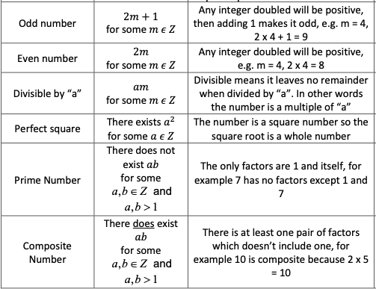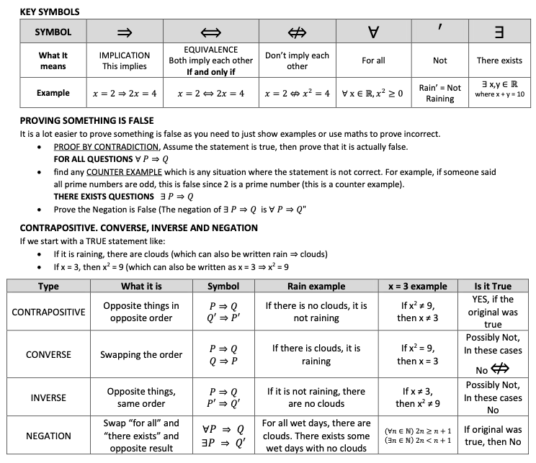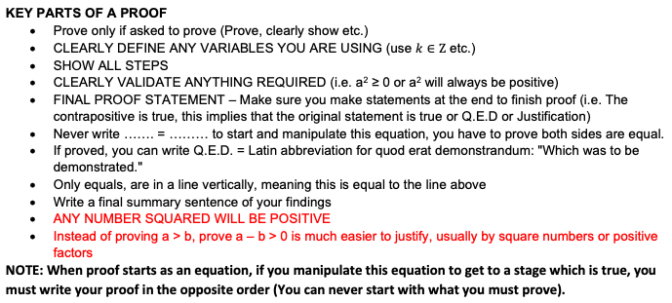

**Conditonal Statement:** It states a condition (if) and tells you a consequence (then)

**Proof Eg:**

When proving that If A then B: You are proving that a causal relationship exists between A and B

1. Assume that A is true, and then
2. Show that B must follow as a consequence

E.g If n is divisble by 7, then n2 is divisible by 49:

1. Assume that n is divisible by 7
2. n = 7m for some integer m
3. n2 = 49m2
4. Since m2 is an integer, n2 is divisible by 49
5. QED (Quad erat demonstratum, meaning as it was demonstrated)

